Active Screen

**Relevant for: GUI** **testing and scripted GUI components**

The Active Screen pane enables you to view snapshots of your application as it appeared during a step in a recording session.

This is another versatile feature that Active Screen Pane provides to make the testing process more transparent to the user. While recording, the Active Screen Pane saves a snapshot of the application state when a certain operation was performed on it. A number of details that you want your active screen to store and record depends on the settings.

Access the Active Screen options pane

To configure the Active Screen options, select **Tools > Options > GUI Testing** tab > **Active Screen** node.

When to use the Active Screen

The more information you capture, the easier it is to edit the test after recording, using the many Active Screen options.

However, more captured information also leads to slower recording and editing times and additional disk space requirements. This is especially critical with Windows-based add-ins, as they require more disk space to save Active Screen data.

Removing or decreasing Active Screen information can be especially useful for conserving disk space after you have finished designing the test and you are using the test only for test runs.

Apply updated options to a test by using Update Run mode or re-recording the steps.

Access the Active Screen pane

1. Do one of the following:

Ensure that a GUI test, action, or component is in focus in the document pane.

In the solution explorer, select a GUI test or component node, or one of its child nodes.

1. Select **View > Active Screen**.

Here I have a test that creates a mail account and I chose to view the active screen. This is how it looks:

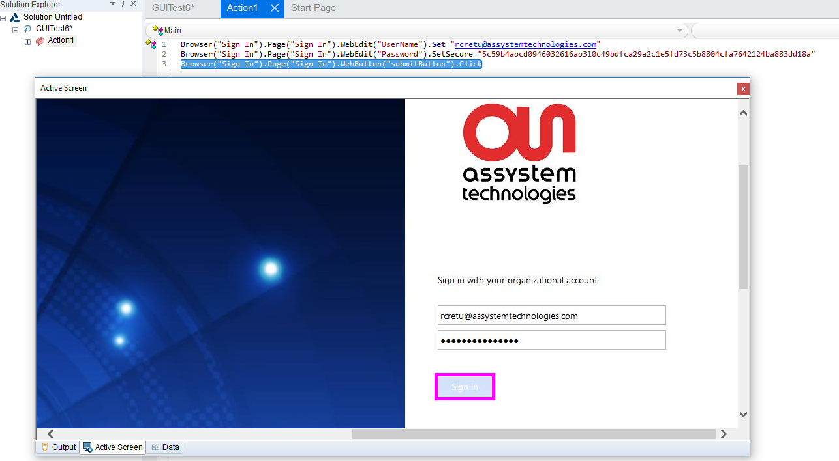

As you can see, when I have the statement selected the corresponding object on which the statement acted upon is highlighted in the snapshot that the active screen has captured.

Let us see what happens when I move to the previous statement.

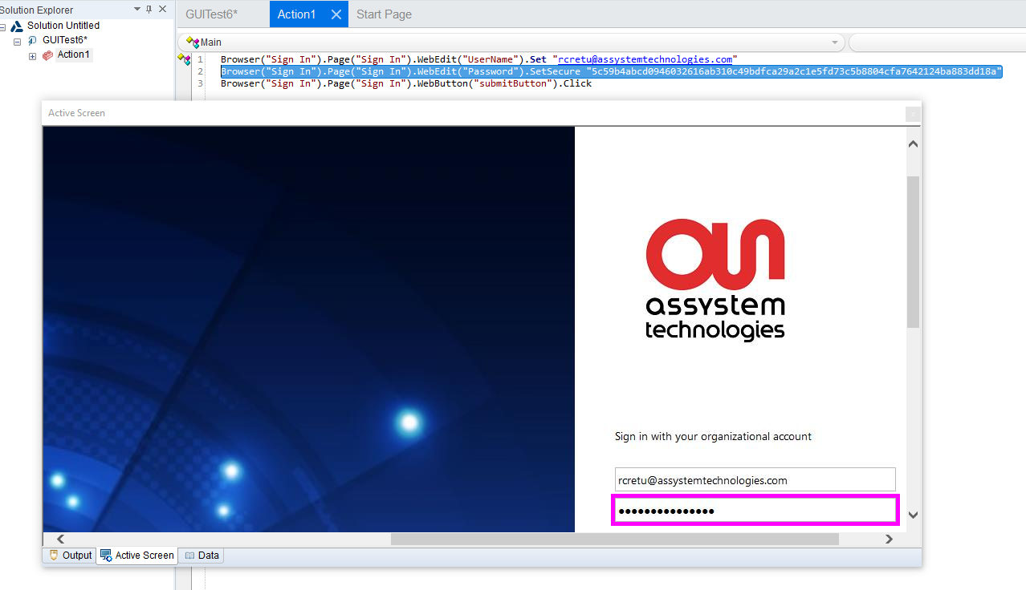

So, the corresponding text box where I am trying to enter the Password is highlighted.

Now let us see what how much of information can we ask UFT to store in this snapshot while recording and how do we do it.

Capture level options

*Choose “Tools->Options->Active Screen” from the menu. It opens up the following window:*

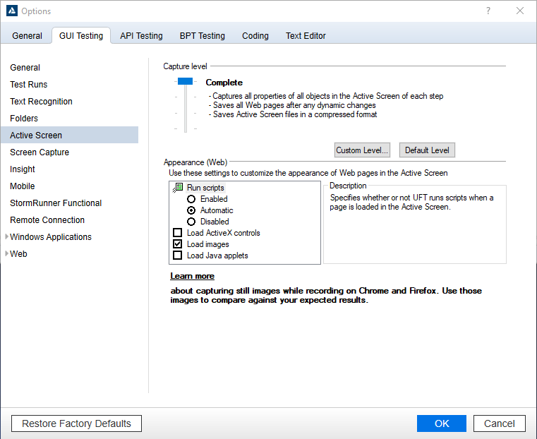

Each level of capture and its corresponding features are explained in this window. The default setting is as you see it in the screenshot.

The following options enable you to specify the objects for which UFT stores data in the Active Screen.

Use the slider or buttons to select one of the following options:

**Complete:**

Captures all properties of all objects in the application's active window/dialog box/Web page in the Active Screen of each step.

This level saves Web pages after any dynamic changes and saves Active Screen files in a compressed format.

**Partial:**

Captures the following:

* All properties, of all objects in the application's active window/dialog box/Web page in the Active Screen of the first step performed in an application's window
* All properties of the recorded object in subsequent steps in the same window.

This level saves Web pages after any dynamic changes and saves Active Screen files in a compressed format.

**Minimum (default):**

Captures properties only for the recorded object and its parent in the Active Screen of each step.

This level saves the original source HTML of all Web pages (prior to dynamic changes) and saves Active Screen files in a compressed format.

**None:**

Disables capturing of Active Screen files for all applications and Web pages.